INDUSTRIAL SURVEYING

3

3

3

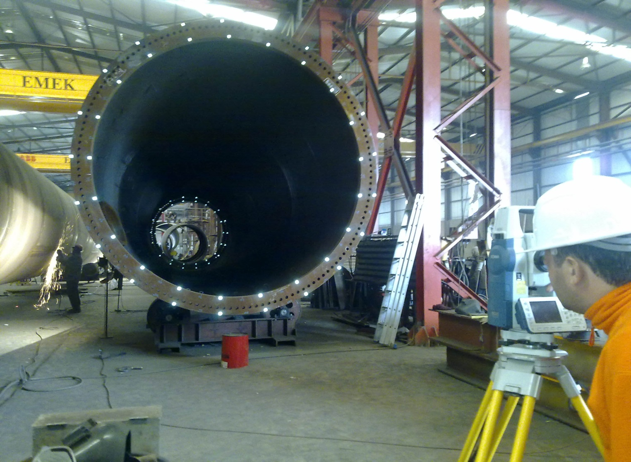

3

High Pressure Natural Gas and Regulating Station, Tema, Ghana

3

3

INDUSTRIAL SURVEYING

INDUSTRIAL SURVEYING

3

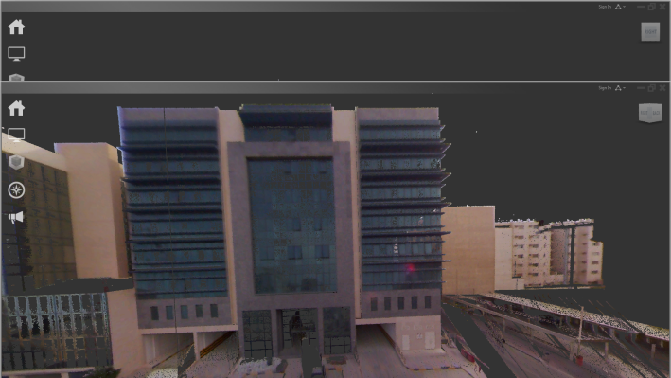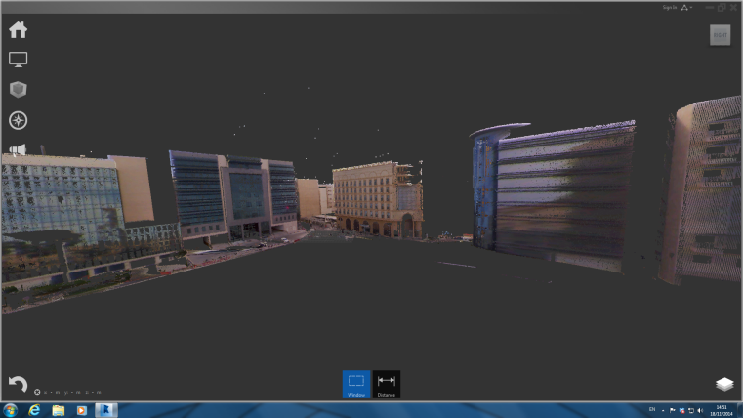

9

* Construction and Geometric Verification of Opera’ s Ferrocement Canopy Panels, Stavros Niarchos Foundation Cultural Center
* Concrete panel’s 3D model creation.
* Measurements of the geometric information from the transverse and longitudinal sections at predetermined points.
* High accuracy requirements for the construction and control of the panels – limit of 2mm
* Each panel’s geometrical verification of the following parameters :
  + Distance between the ribs (vertical beams)
  + Deviations of ribs axes
  + Width of the ribs
  + Distance between the beams
  + Deviations of beams axes
  + Width of the beams
  + Flange thickness
* Façade As-Built Survey at CRing – Doha, Qatar
* Low time of data acquisition comparing to classical methods
* Non-invasive method for collecting data
* Optimum cost of works
* Authentic, full and accurate 3D copy of reality
* 2D and 3D documentation for engineers, structure designers, architects.
* Production of 2D drawings or 3D models for refurbishment and restoration project, compatible with all CAD software.
* Structural details – complex documentation based on the accuracy and large volume of data
* Reconstruction of complex architectural elements
* Internal building survey for floor plans
* 3D urban modeling for planning studies
* Detailed architectural scanning for preservation
* BIM model creation

COMPANY’S EXPERIENCE – INDUSTRIAL APPLICATIONS

3D view of a point cloud produced from the scanning session

A typical ferrocement panel

Façade As- Built at CRing – Doha, Qatar

Façade As- Built at CRing – Doha, Qatar

10

LASER SCANNING & BIM

5

www.aksm.gr

3

**SURVEYING PRECISION**

INDUSTRIAL SURVEYING

Surveying Precision

www.aksm.gr